**AIM :-**

**Forensics Case Study** : Solve the Case study (image file) provide in lab using Encase Investigator or Autopsy.

**Step 1** : Open Autopsy.

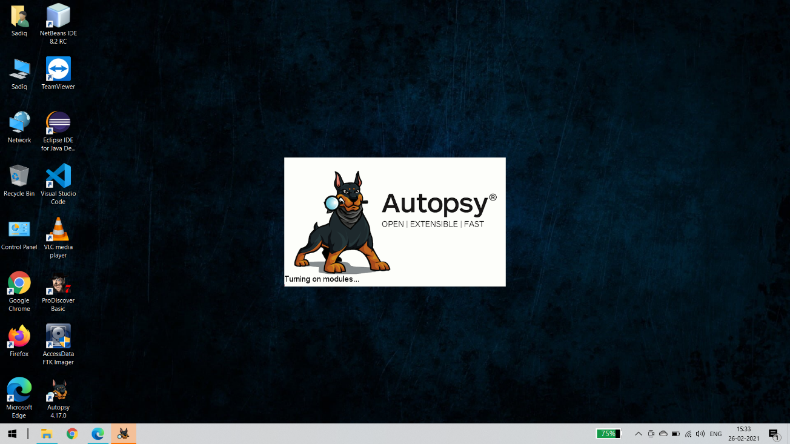

**Step 2** : Click on new case

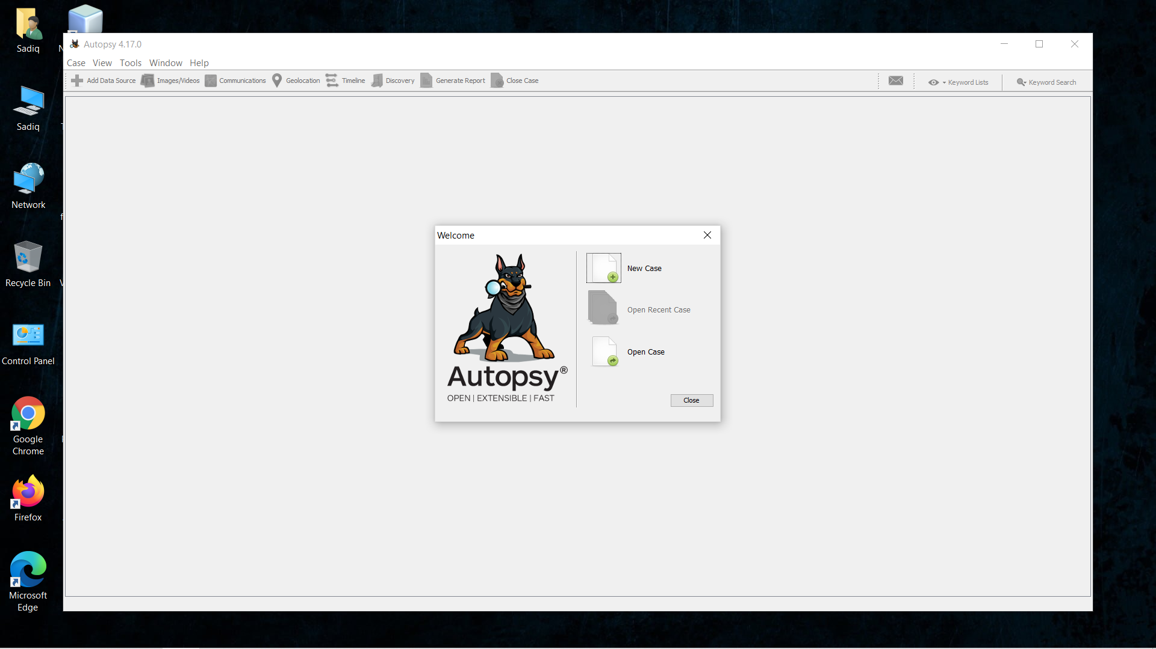

**Step 3** : Enter details regarding the case and click on next button.

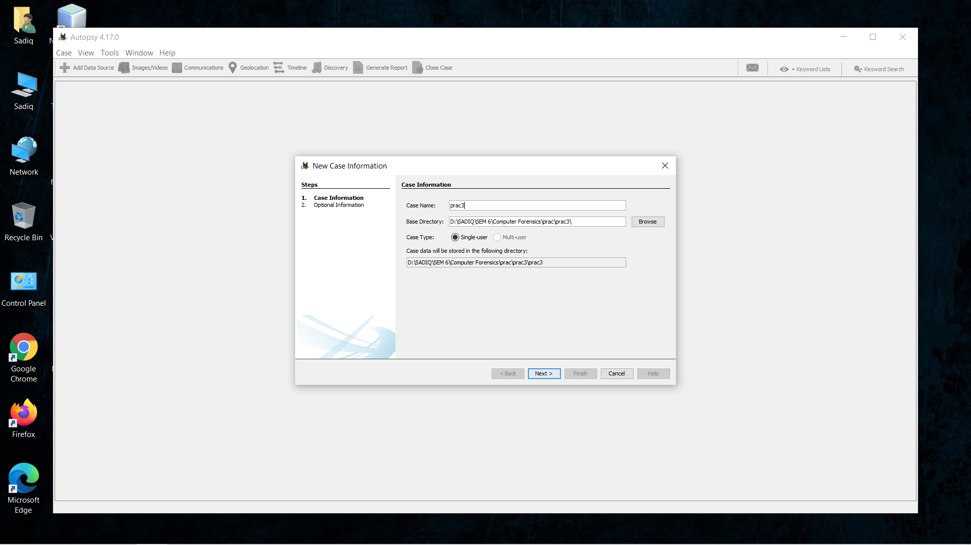

**Step 4** : Enter further details and click on next button:

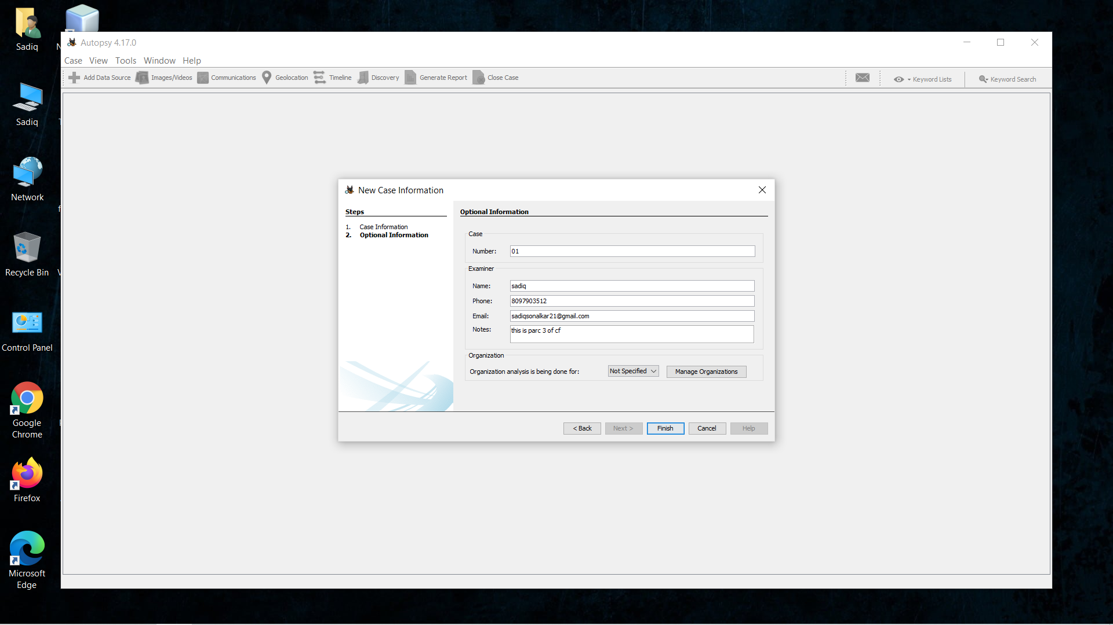

**Step 5** : Now here we have to select Type of data source to add , in our case local disk and click on next

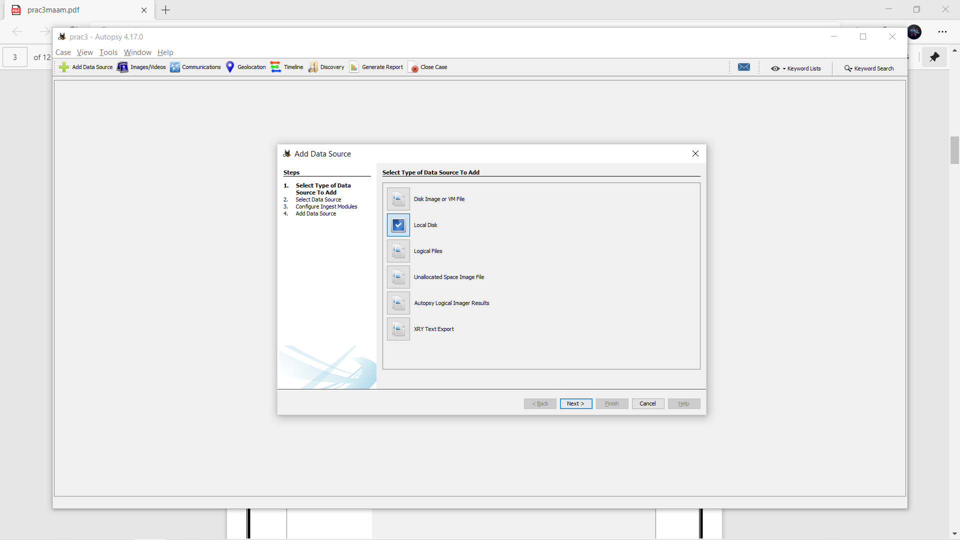

**Step 6** : Now we have to select local disk and click on next button

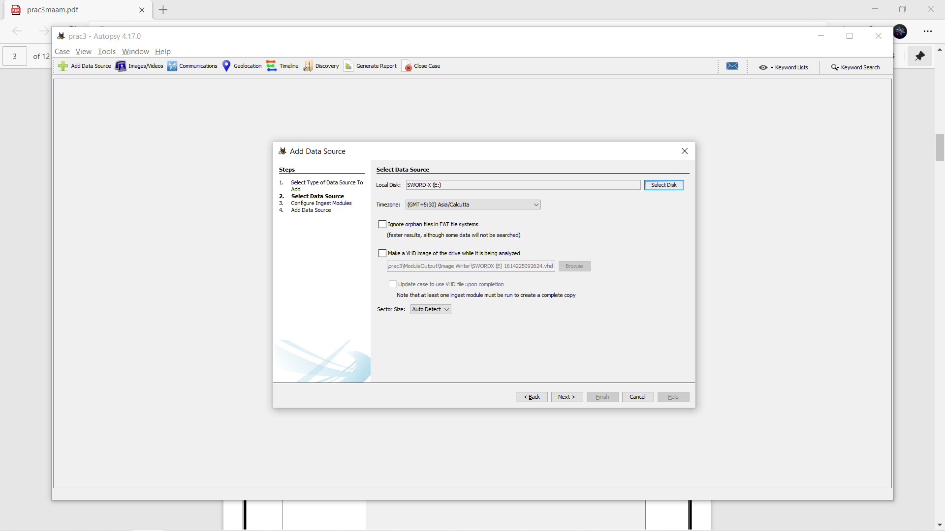

**Step 7** : Now click on select all in order to Run ingest modules on: and click on next.

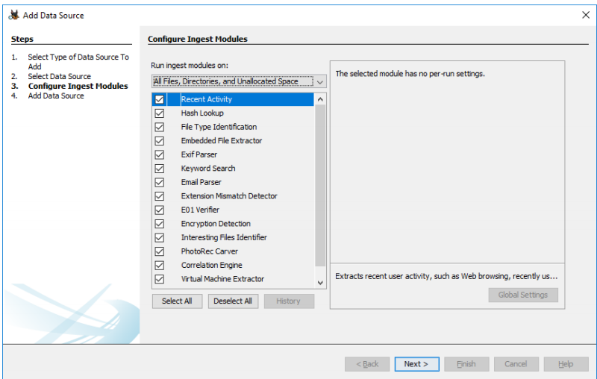

Loading will take place

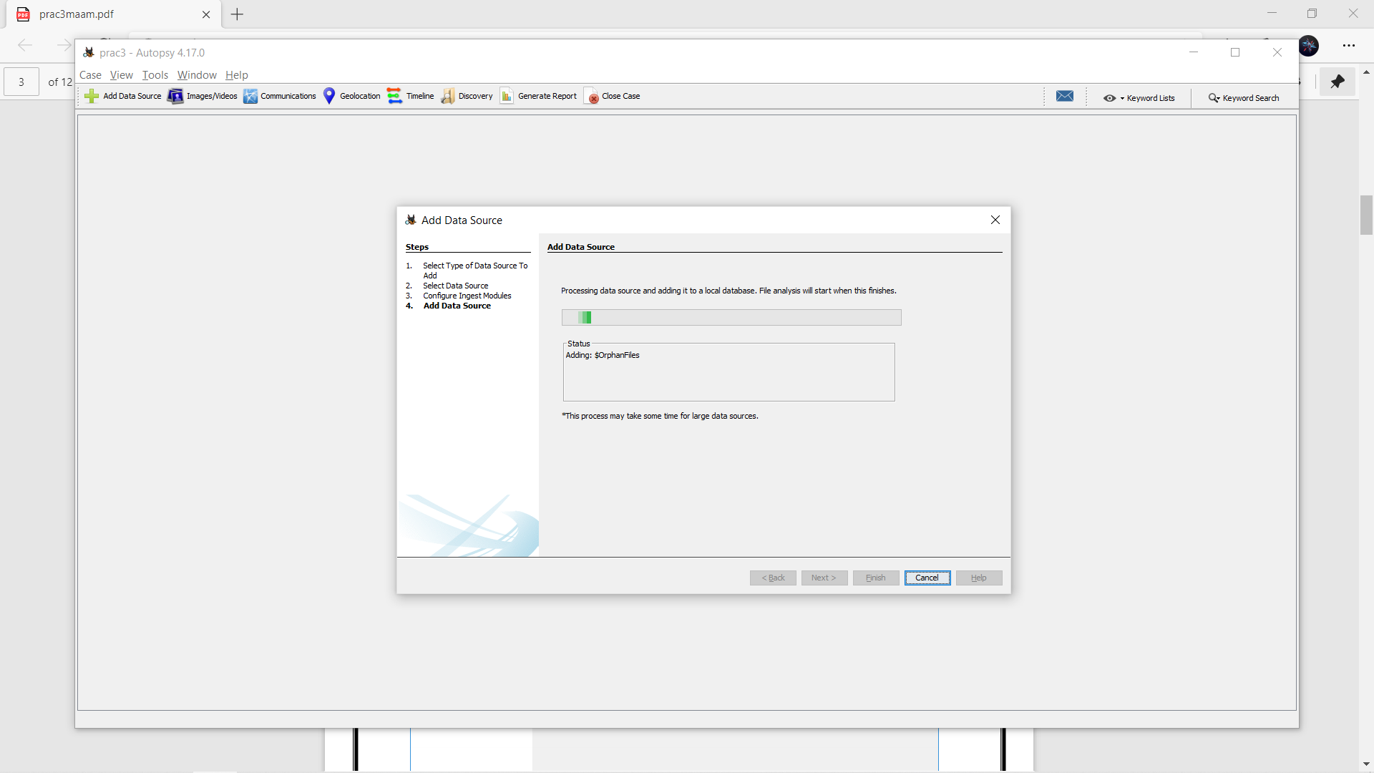

**Step 8** : Now click on finish

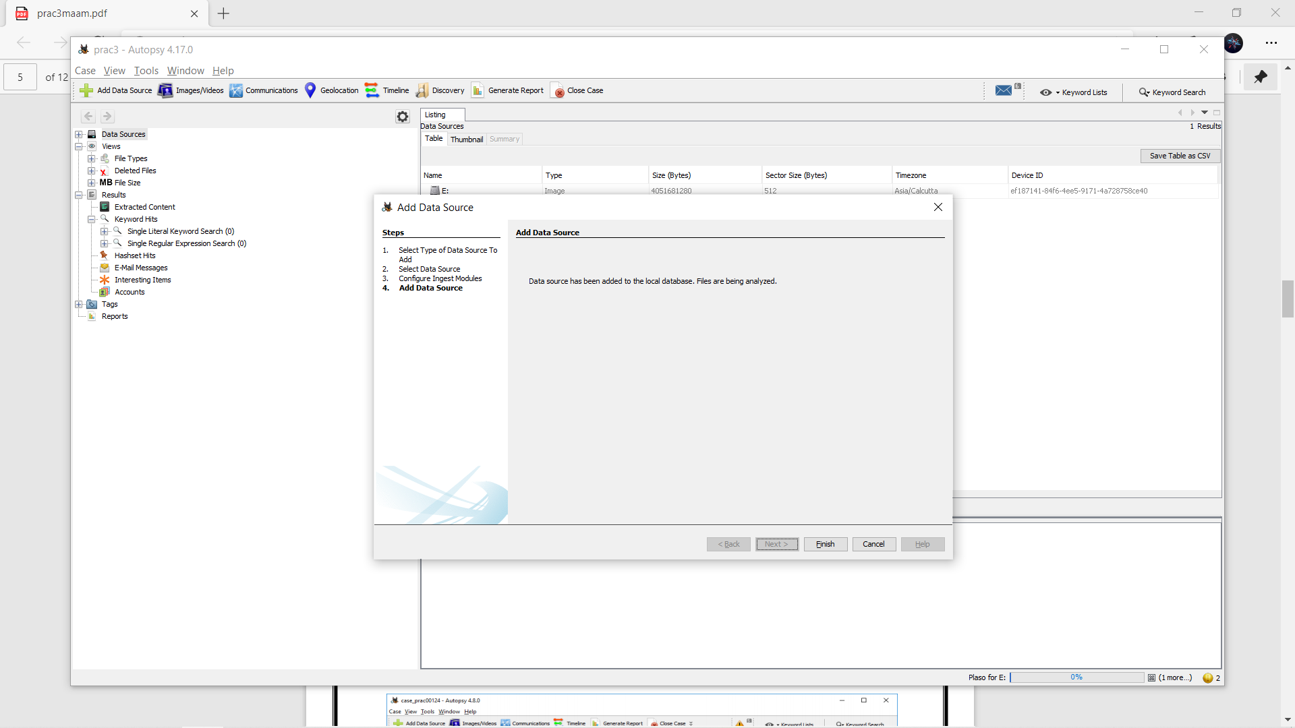

**Step 9** : Now Autopsy window will appear and it will analyse the disk that we have selected .

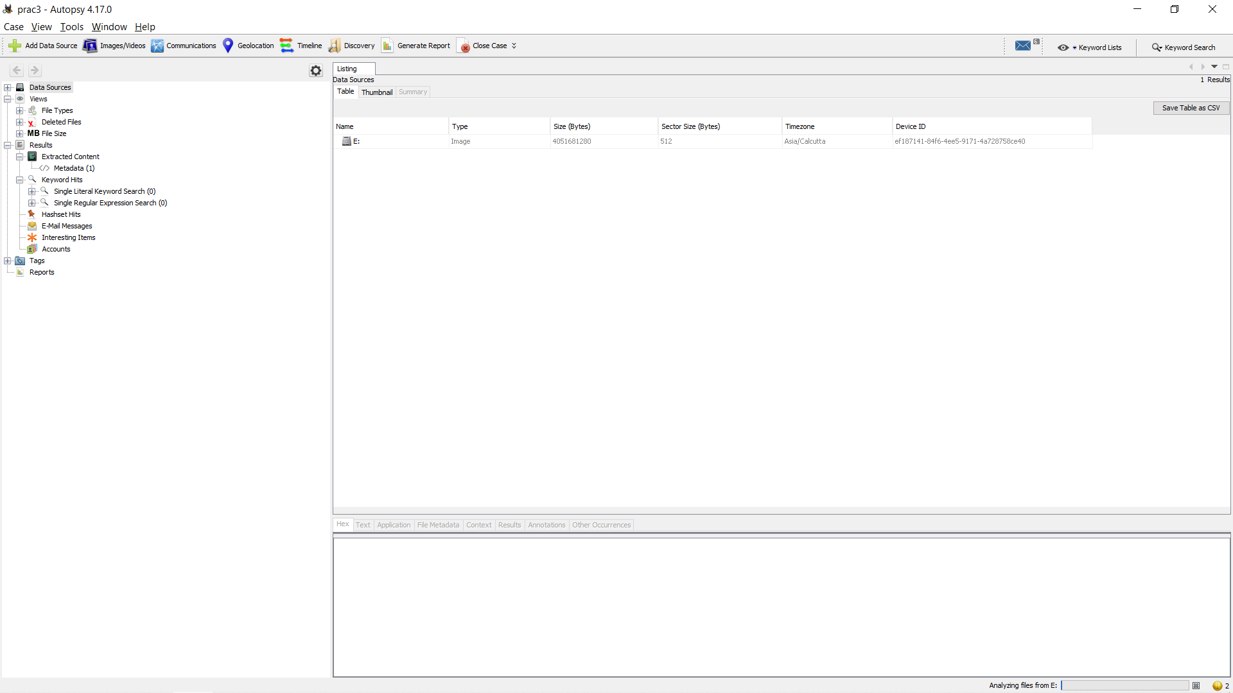

**Step 10** : All image files appears in the Table tab. Select any file to see the data

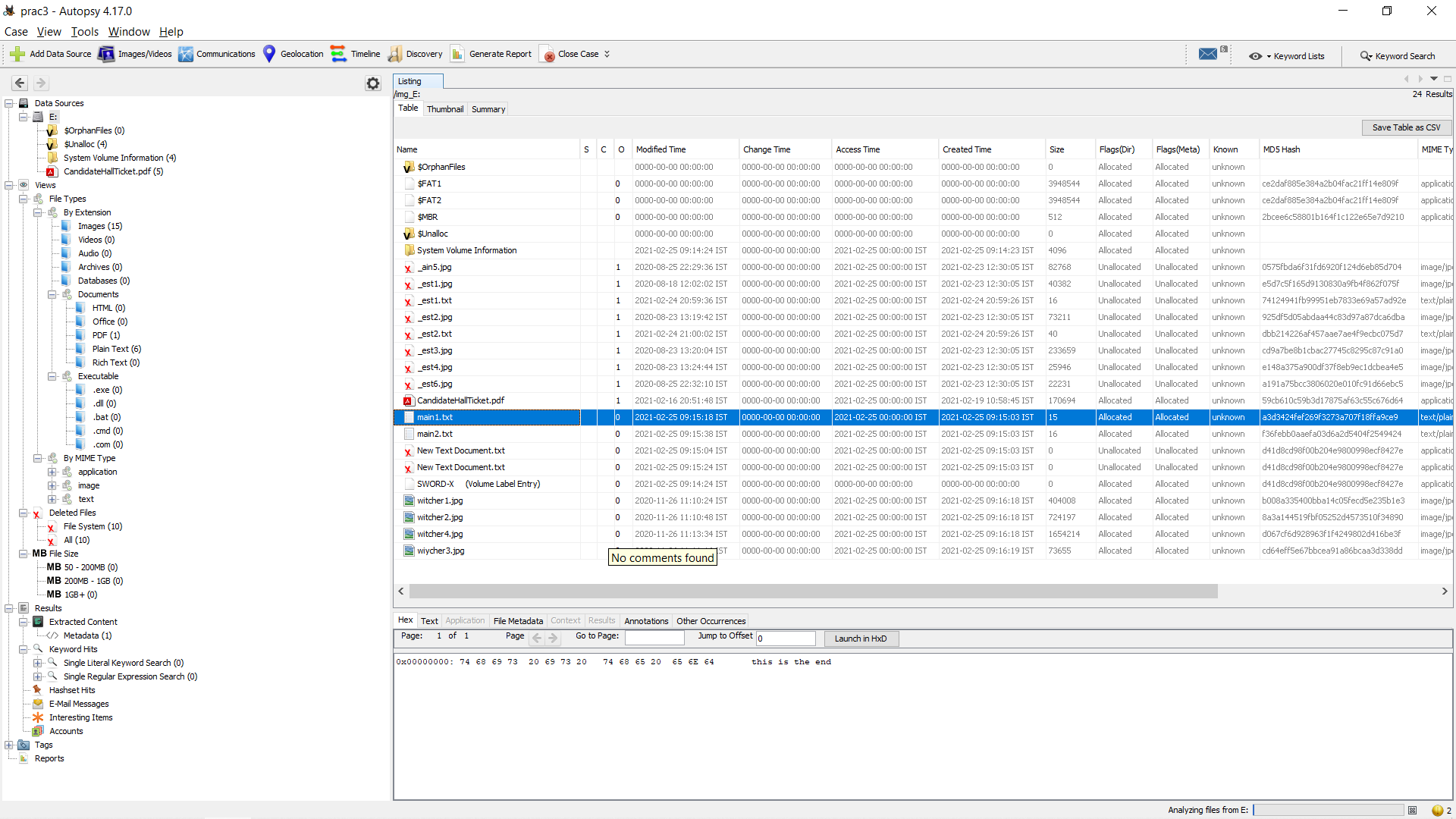

Step 11 : Expand the tree from left side panel to view the document files.



**Step 12** : To recover the files , go to view code Deleted files node , here select any file and right click on it then select Extract files option

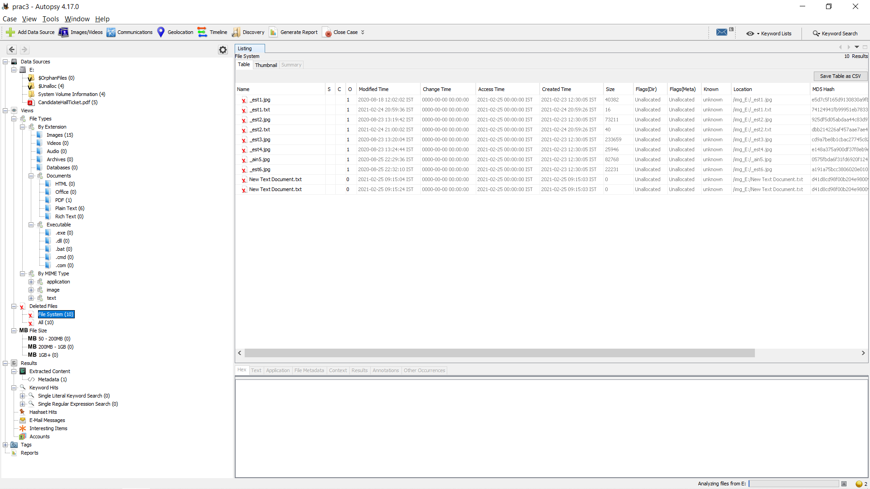

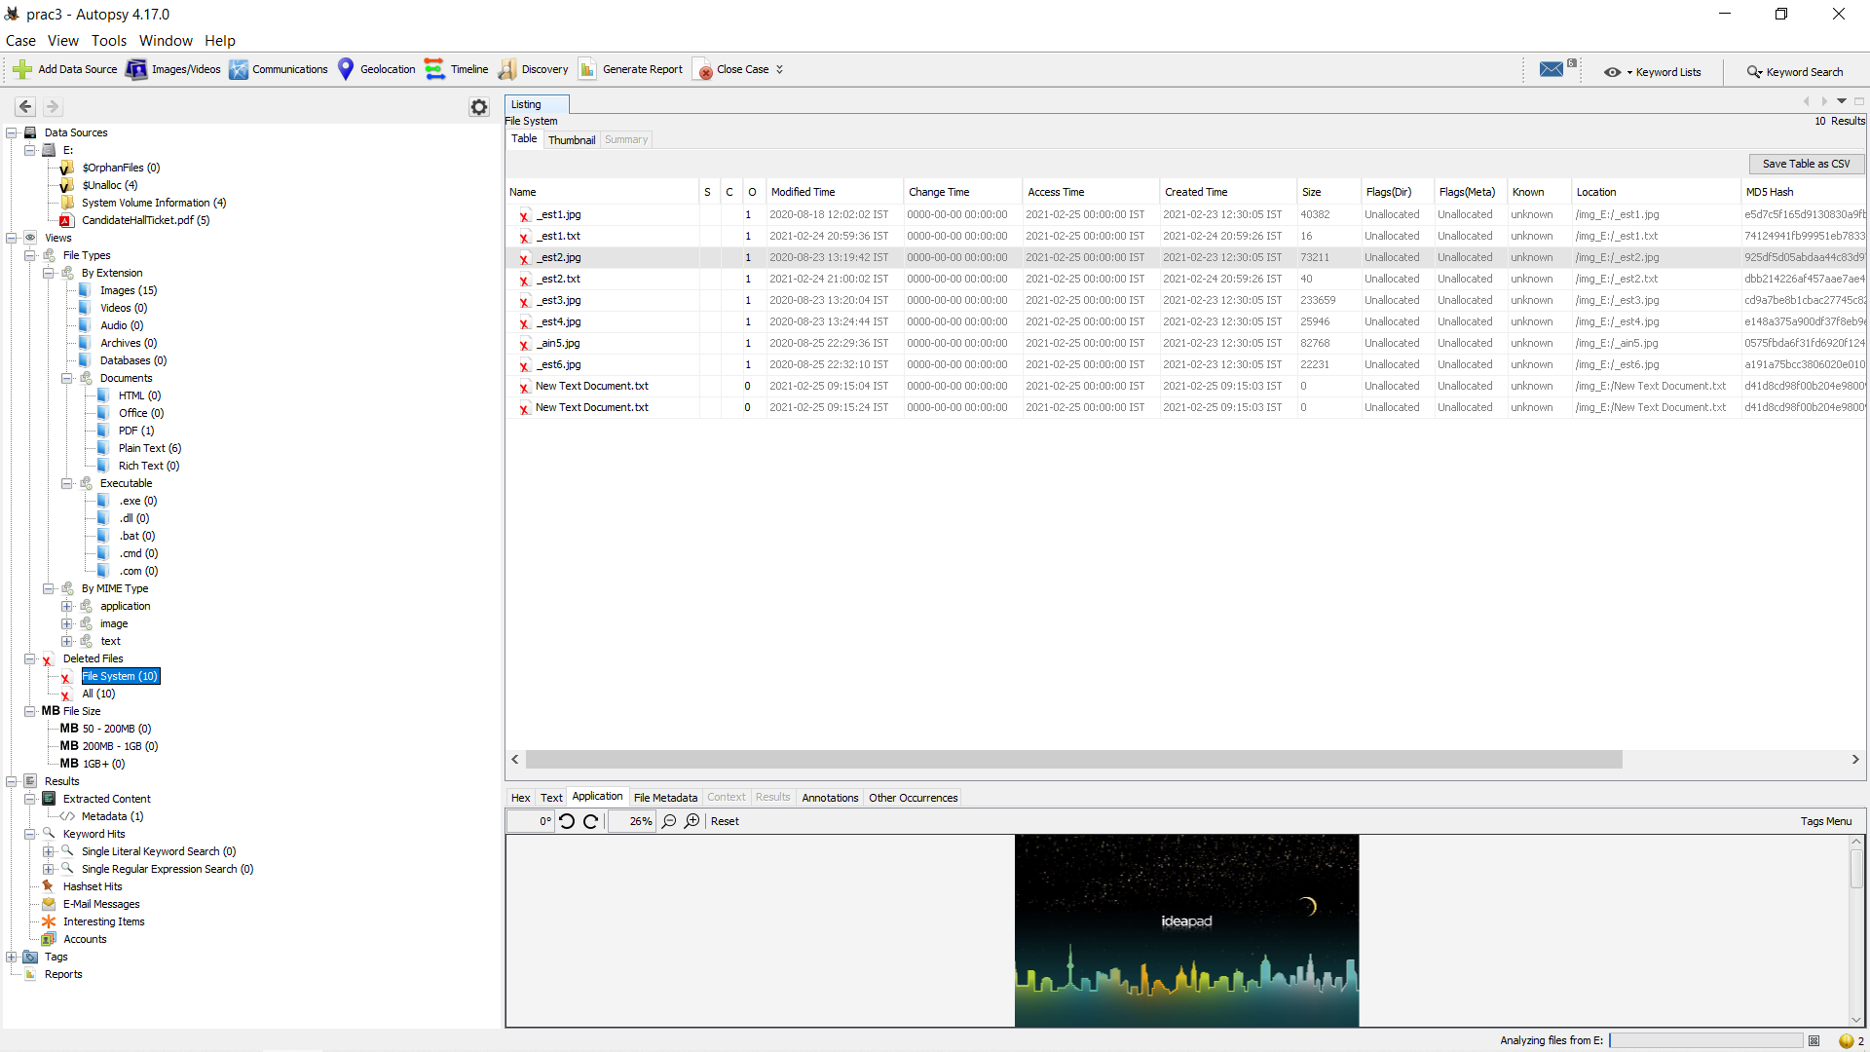

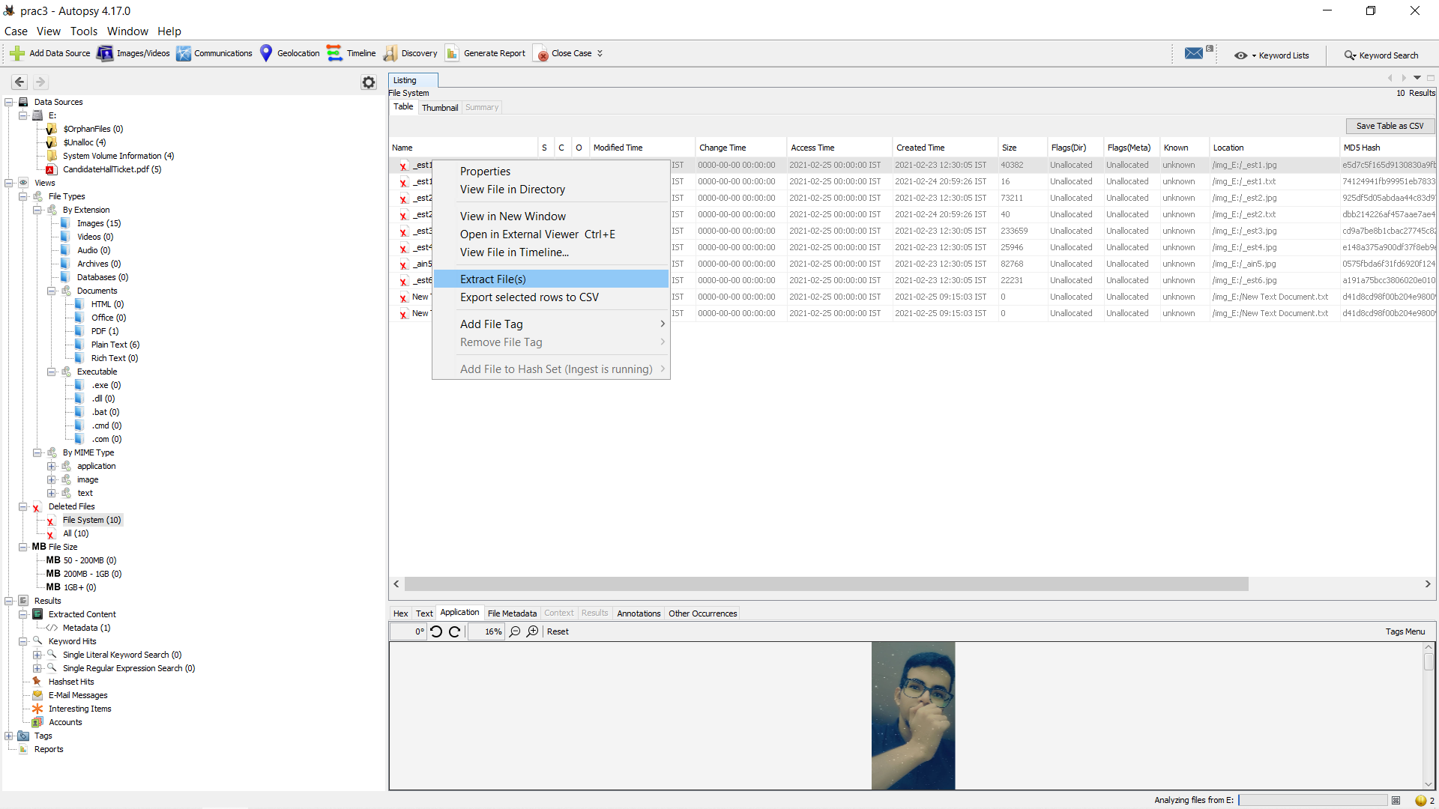

**Step 13**: Select Path where you want to save extracted file and click on save .

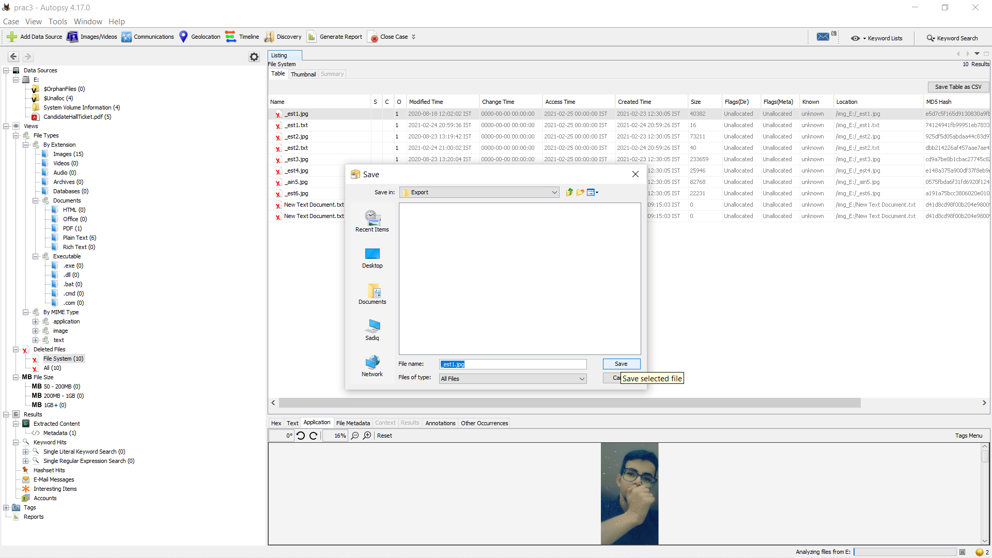

**Step 14** : Now click on OK

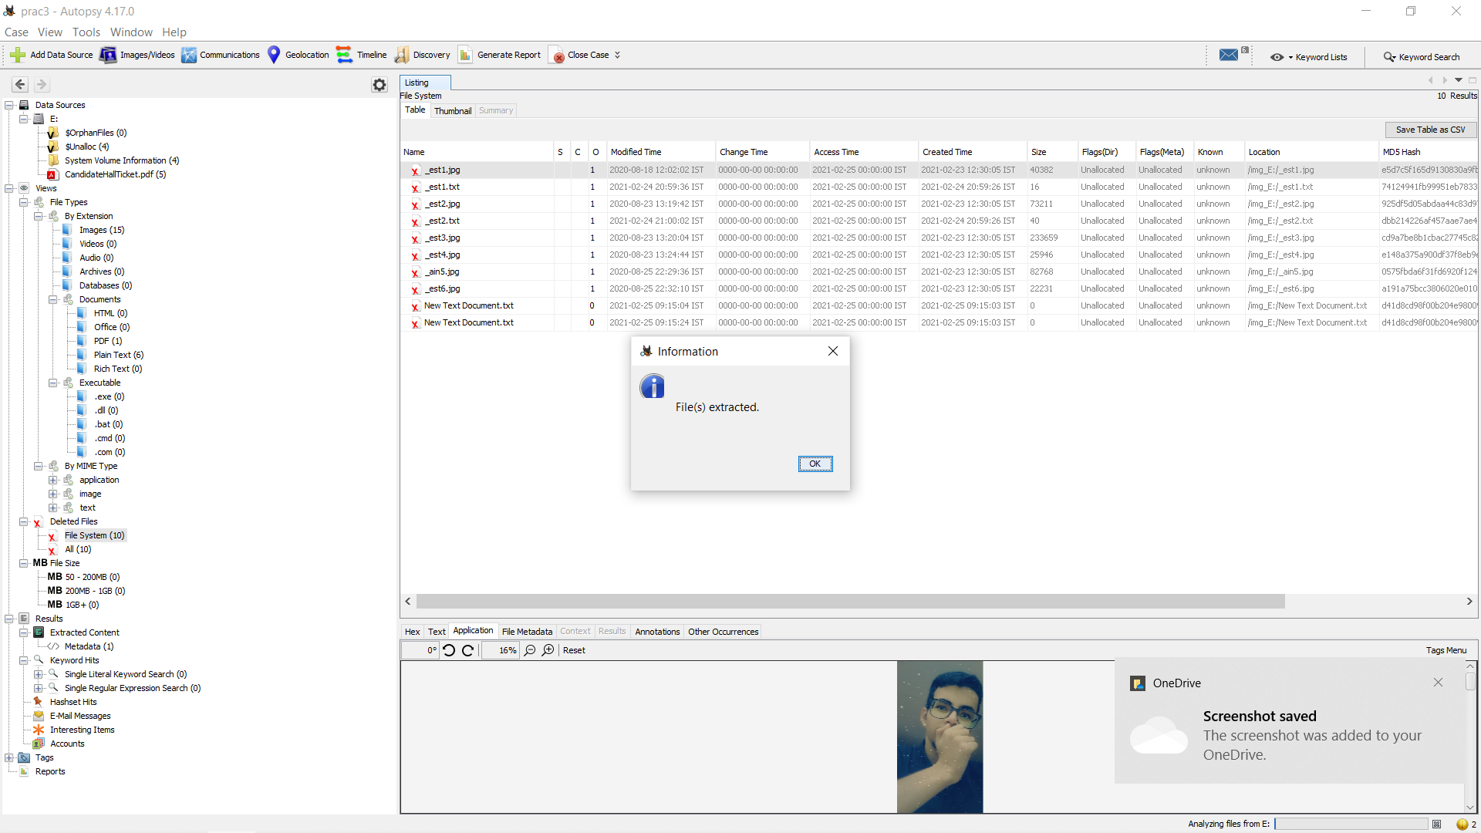

**Step 15** : Now go to “D:\SADIQ\SEM 6\Computer Forensics\prac\prac3\prac3\Export” folder to see recover file.

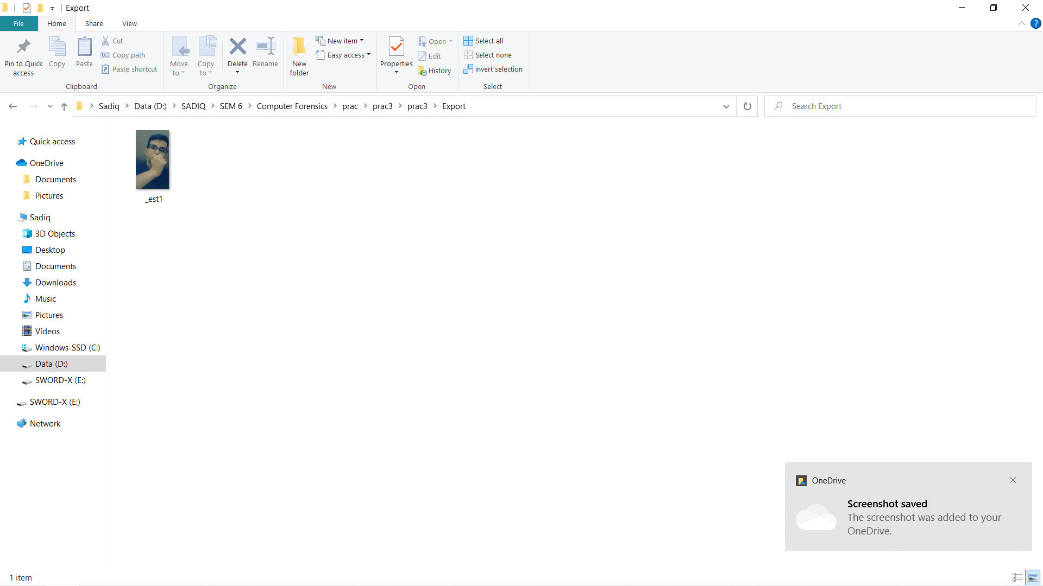

**Step 16 :** Click on generate report from Autopsy window and select the HTML format and click on next

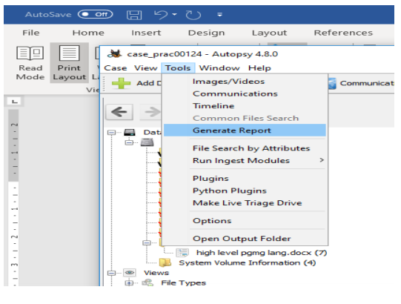

**Step 17** : This window will appear. Enter header and footer

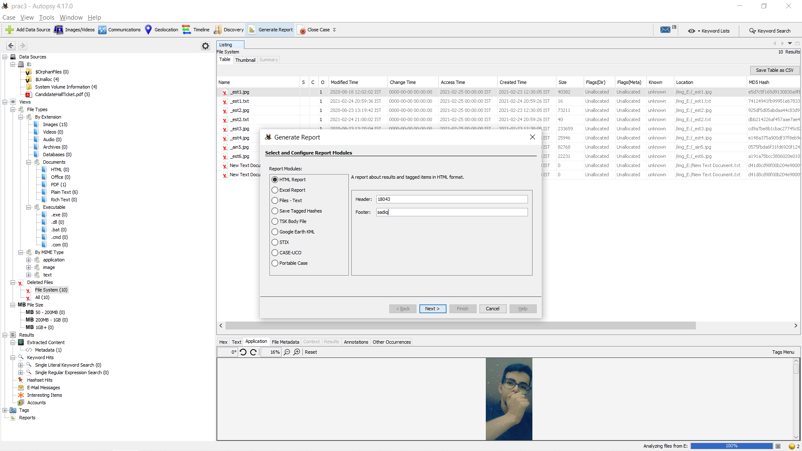

**Step 18 :** Click on generate report from Autopsy window and select the excel format and click on next

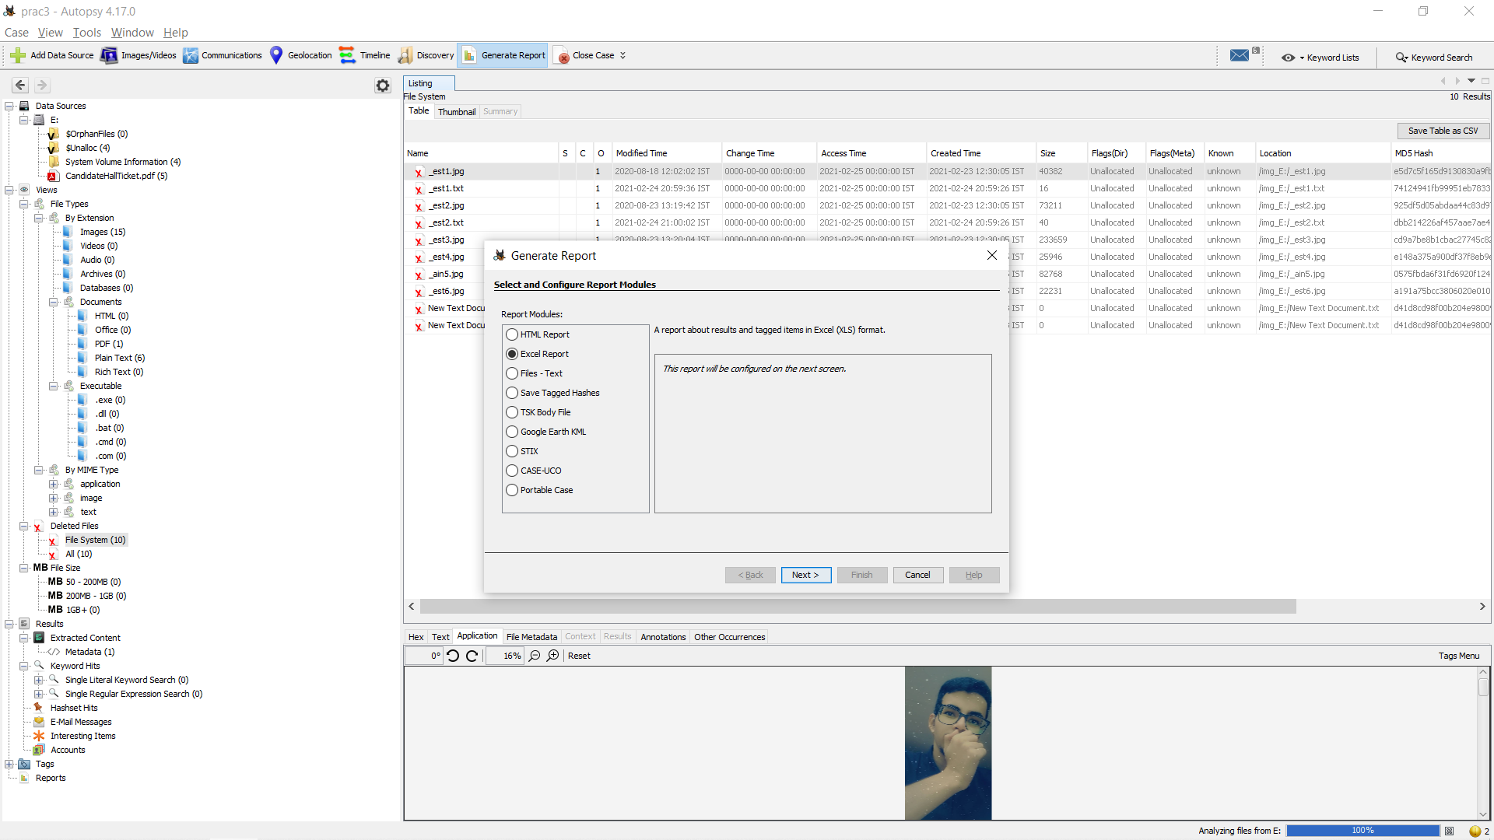

Proceed with the formalities

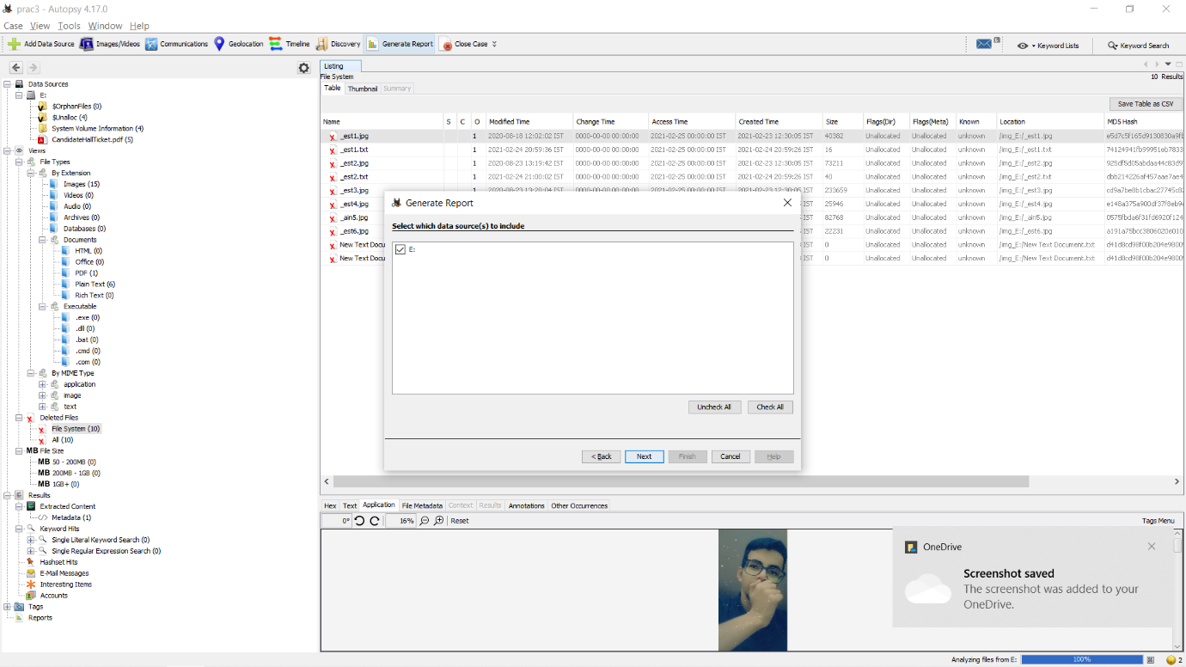

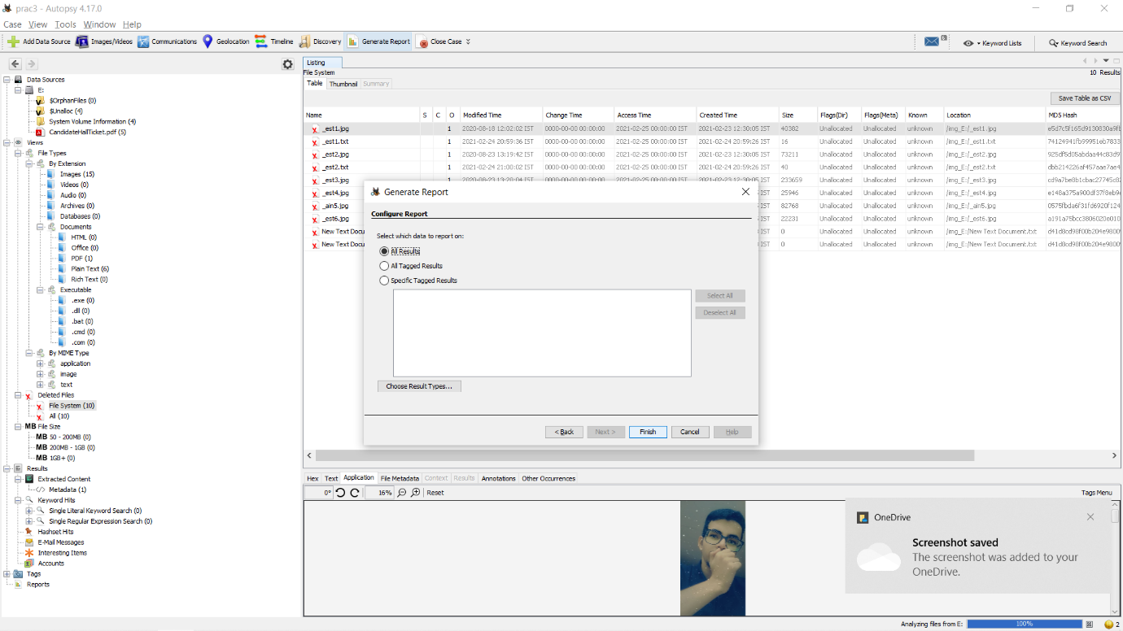

**Step 19** : Now report is generated so click on close button. We can see the Report on Report Node

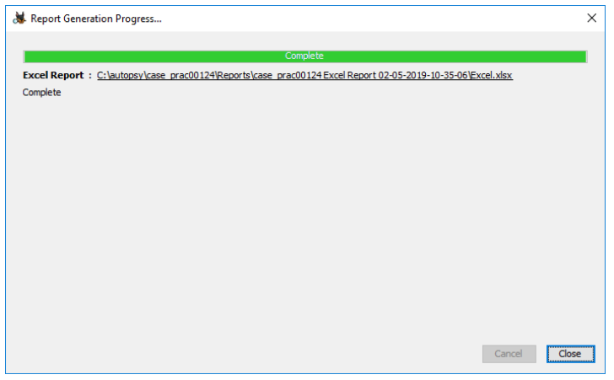

**Step 20** : Click on report

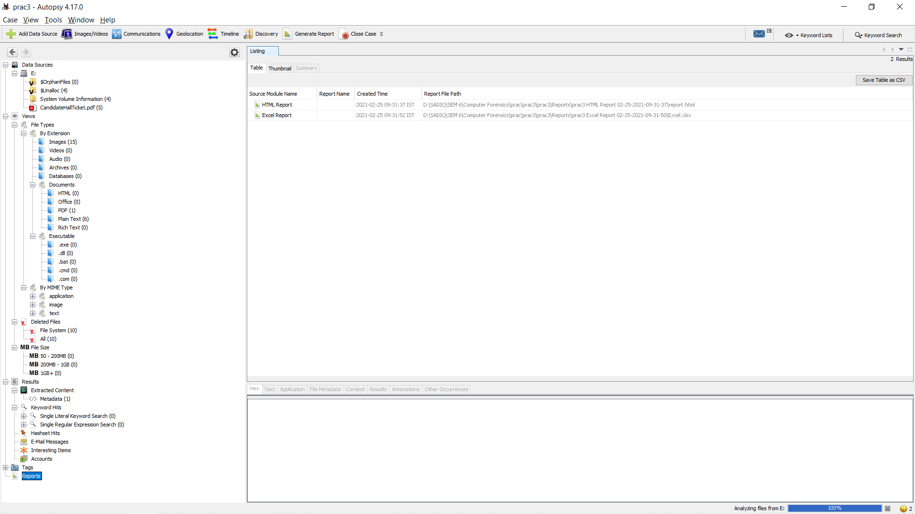

**Step 21** : Click on report and you will see the result.

**HTML Report:**

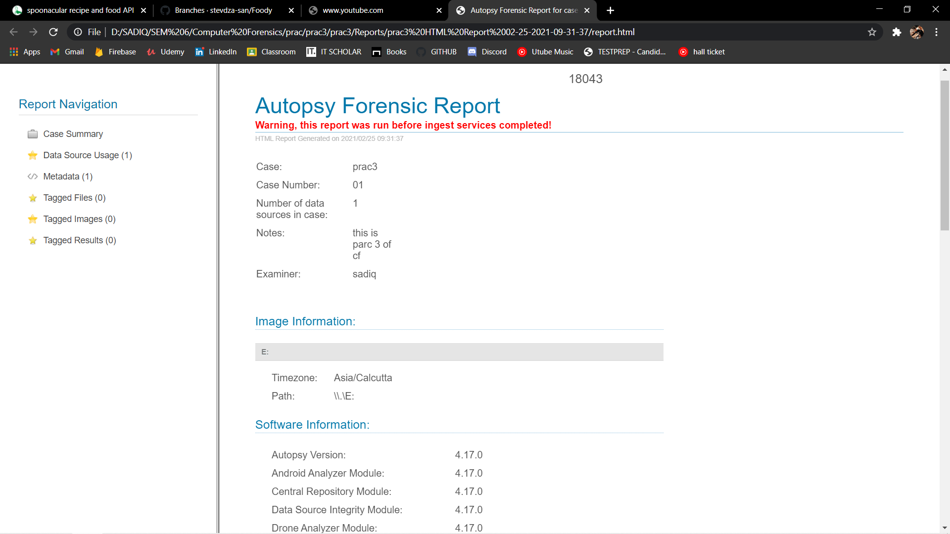

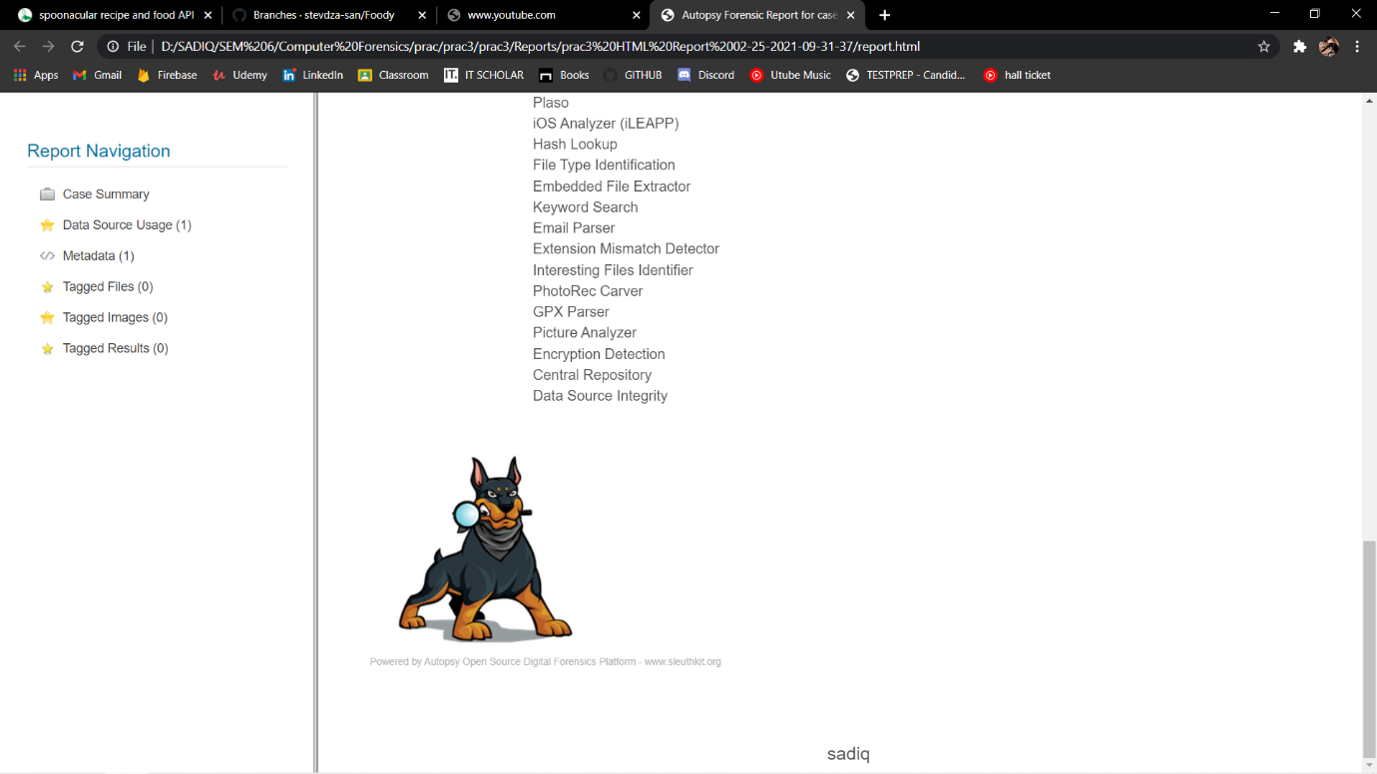

You will see your header and footer you entered while making the HTML report.

**EXCEL Report:**

